**ENGR.** **MD. MAHABUB HASAN**

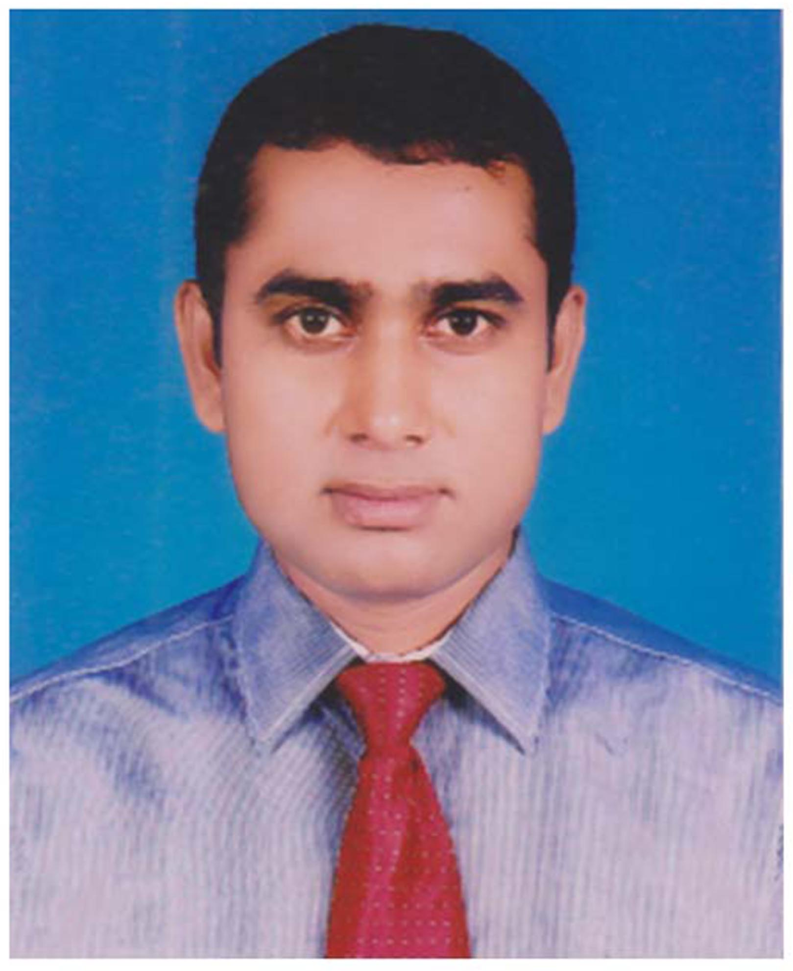

Address: Amina Monzil, 263/1, Flat 5-A, Ahammed Nagor, Mirpur-1, Dhaka 1216.  
Primary Mobile No: 01554587190   
Secondary Mobile No :01916486503   
Emergency Contact No: 01922556115   
Primary Email: [mahabub1625@gmail.com](mailto:mahabub1625@gmail.com)   
Alternate Email: [mahabub96@ymail.com](mailto:mahabub96@ymail.com)

**Career Objective:**

To secure a challenging professional in a reputed organization. Having excellent interpersonal skill, hardworking, self-motivated, energetic, positive work attitude & ability work effectively with a team under pressure & love challenges.

**Career Summary:**

More than 13 years professional experience in maintenance & production & inspection, expertise in planning, organizing, monitoring, controlling. Worked in a competitive & dynamic field with satisfied value also interpersonal skills to enhance organizational goals.

**Special Qualification:**

Familiar with Microsoft Office, E-Mailing & Internet Browsing, Web Design, Web Development, HTML, CSS, JavaScript, Computer Hardware Maintenance, Graphics Design, Video Editing, CCNA.

**Employment History:**

**Total Year of Experience:** 13 yrs.

1. **Assistant Engineer-Mechanical (3 yrs.)**

(April, 2020 - Continuing)

**Bangladesh Insulator & Sanitaryware Factory Limited.**

Bux Nagor, Mirpur-1, Dhaka-1216, [www.bisfl.gov.bd](http://www.bisfl.gov.bd)

Main Resource & Production Insulator, Sanitaryware, Refractory Bricks, Souvenir.

**Area of Expertise.**

Maintenance & Troubleshooting.

**Duties/Responsibilities**

Managerial All Works Mechanical, Electrical, Civil, ICT & Meeting with Authority.

1. **Assistant Engineer-Mechanical (.5 yrs.)**

(October, 2019 - March, 2020)

**Dap Fertilizer Company Limited,** Rangadia, Anowara, Chittagong, <http://www.dapfcl.gov.bd/>

**Area of Expertise**

Maintenance & Troubleshooting.

**Duties/Responsibilities**

Managerial All Works Mechanical, Electrical, Civil, ICT & Meeting with Authority.

1. **Assistant Engineer-Mechanical (6 yrs.)**

(December, 2013 - October, 2019)

**Urea Fertilizer Factory Limited (UFFL),** Palash, Narsingdi-1611, <http://www.uffl.gov.bd/>

**Area of Expertise**

Maintenance & Troubleshooting.

**Duties/Responsibilities**

Managerial All Works Mechanical, Electrical, Civil, ICT & Meeting with Authority.

1. **Industrial Surveyor-Electrical (.5 yrs.)**

(June, 2013 - December, 2013)

**Bureau Veritas (Bangladesh) Private Limited,** <https://www.bureauveritas.com.bd/>

Haque Chamber, 89/2, West Panthopath, Level-6, Dhaka-1205

**Area of Expertise**

Factory/ Plant/ Facility Management.

**Duties/Responsibilities**

Garments, Textile Electrical Audit & Submit Report to Authority.

1. **Production Supervisor (3 yrs.)**

(September, 2009 - June, 2012)

**OTOBI Limited,** Plot I/5, Road no 6, Section 7, Mirpur Dhaka 1216. <https://otobi.com/>

**Area of Expertise**

Factory/ Plant/ Facility Management.

**Duties/Responsibilities**

Making a Production & Submit Report to Authority.

1. **Certification:** Electricity Licensing Board, Bangladesh.

**Electrical Supervisor License Number:** S20210000688

**Category:** ABC

<https://ocei.portal.gov.bd/>

**Academic Qualification:**

|  |  |  |  |  |  |
| --- | --- | --- | --- | --- | --- |
| **Exam Title** | **Concentration/Major** | **Institute** | **Result** | **Years** | **Duration** |
| **Master of Science in Environmental Science & Engineering (MSESE)** | **Environmental Science & Engineering** | **State University of Bangladesh** | CGPA:3.54 out of 4 | **2023** | **1.5 years** |
| Master of Business Administration (MBA) | Finance & Banking | Prime University | CGPA:3.15 out of 4 | **2015** | 2 years |
| Bachelor in Engineering (BEng) | Bachelor of Science in Electrical & Electronic Engineering | Atish Dipankar University of Science & Technology | CGPA:3.24 out of 4 | **2012** | 4 years |
| Diploma in Engineering | Mechanical Technology | Jessore Polytechnic Institute | CGPA:2.78 out of 4 | **2008** | 4 years |
| SSC (Vocational) | General Mechanics | Shailkupa Pilot High School | CGPA:3.41 out of 5 | **2004** |  |

**Training Summary:**

|  |  |  |  |  |  |  |
| --- | --- | --- | --- | --- | --- | --- |
| **Training Title** | **Topic** | **Institute** | **Country** | **Location** | **Year** | **Duration** |
| Basic Graphics Design | Graphics Design | PENTANIK IT | Bangladesh | Dhaka | 2022 | Two Month |
| National Portal Management | Government Portal Management | ICT DIVISION | Bangladesh | E-14 10, ICT TOWER, Dhaka 1207 | 2022 | 03 Month |
| e-Nothi (e-Filing Management) | e-Filing Management | ICT DIVISION | Bangladesh | E-14 10, ICT TOWER, Dhaka 1207 | 2022 | One Month |
| HTML5, CSS3 & Bootstrap 4 For Web Development | HTML5, CSS3 & Bootstrap 4 For Web  Development | BOHUBRIHI | Bangladesh | Banani, Dhaka 1213 | 2022 | Six Month |
| National e-Government Procurement (e-GP) System as Procuring Entity (PE) User. | National e-Government Procurement. | Ministry of Planning | Bangladesh | Dhaka | 2021 | Five Day |
| Responsive Web Design & Freelancing | Web Design & Freelancing | TRENDUP IT | Bangladesh | Mirpur-10, Dhaka-1216 | 2021 | 03 Month |
| Graphic Design & Freelancing | Graphic Design | TRENDUP IT | Bangladesh | Mirpur-10, Dhaka-1216 | 2021 | 03 Month |
| Advance Social Media Marketing & Online Business | Social Media Marketing & Online Business | TRENDUP IT | Bangladesh | Mirpur-10, Dhaka-1216 | 2021 | 03 Month |
| Practical Training Course in Electrical Engineering | Practical Training in Electrical | Multipurpose Engineering & Industrial Automation (MEIA) | Bangladesh | Joydebpur, Gazipur-1700 | 2021 | One Day |
| Village Doctor Refresher Training | Primary Health Care | Civil Surgeon Office | Bangladesh | Dhaka | 2019 | One Month |

**Professional Qualification:**

|  |  |  |  |  |
| --- | --- | --- | --- | --- |
| **Certification** | **Institute** | **Location** | **From** | **To** |
| Energy Efficiency & Conservation in Common Technology | Ministry of Power, Energy & Mineral Resources | Dhaka | February 22, 2022 | February 23, 2022 |
| Effectively Use Productivity Tools & Technic | National Productivity Organization (NPO) | BISFL, Mirpur-1, Dhaka-1216 | June 21, 2021 | June 24, 2021 |
| Diploma in Medicine & Surgery (DMS) Training Course | Adhorsho First Aid Training Center | Mirpur-01, Dhaka-1216 | June 01, 2021 | May 30, 2022 |
| AutoCAD (2D) | Engineering Staff College, Bangladesh | Ramna, Dhaka-1217 | February 14, 2021 | March 23, 2021 |
| Practical Training Course in Electrical Engineering | Multipurpose Engineering & Industrial Automation (MEIA) | Joydebpur, Gazipur-1700 | November 20, 2019 | November 20, 2021 |
| Programmable Logic Controller (PLC) & Programmable Instrument | Training Institute for Chemical Industries (TICI) | Sarkarkhana, Palash, Narsingdi-1611 | January 25, 2015 | February 5, 2015 |
| Practical Training Course in Mechanical Engineering | KHULNA SHIPYARD LIMITED | Khulna | October 22, 2007 | January 13, 2008 |

**Career & Application Information:**

Looking For: Job

Available For: Full Time/Part Time

Salary: Negotiable

Expected Salary: Negotiable

Preferred Job Category: Education/Training/Engineer/Architect/NGO/Development/Manufacturing Process.

Preferred District: Anywhere in Bangladesh.

Preferred Organization Types: Manufacturing Process/Education/Training/Engineer/NGO/Development.

**Specialization:**

Electrical & Electronic, Industrial & Production Engineering, Mechanical, Electrical, Civil, ICT, Manufacturing Process.

**Extra-Curricular Activities:**

Cricket, Football, Playing Musical Instrument Guitar, Keyboard, Harmonium, Traveling, Reading Novels.

**Language Proficiency:**

English Language Writing & Speaking.

**Personal Details:**

Father's Name: Md. Mokaddes Hossain

Mother's Name: Mst. Hasina Khatun

Date of Birth: January 3, 1987

Gender: Male

Height: 5 Feet 7 Inch

Weight: 65 KG.

Marital Status: Married

Nationality: Bangladeshi

National Id No. 9139135215

Religion: Islam

Passport No: A00245619

Passport Issue Date: 2/16/2021

Permanent Address: Chotomoukuri, Katlagari, Shailkupa, Jhenaidah-7320

Current Location: Mirpur-1, Dhaka-1216

Blood Group: B+ve

**Reference (s):**

**Reference: 01**

Name: Dr. Md. Mohiuddin

Organization: Training Institute for Chemical Industries (TICI).

Designation: Executive Director

Address: Palash, Narsingdi

Mobile: 01791-380652

Relation: Professional

**Reference: 02**

Name: Engr. Md. Abdul Hannan

Organization: Bangladesh Insulator & Sanitaryware Factory Limited (BISFL).

Designation: General Manager (MTS)

Address: Zoo Road, Bux Nagor, Mirpur-1, Dhaka-1216

Mobile: 01706-302522

Relation: Professional

**Declaration:**

It is sincerely acknowledged by me that above all information about me is true & correct.

Sincerely Yours



MD. MAHABUB HASAN